## 



FSD IITR Capstone - CONTENT

PROJECT DOCUMENTATION

0.0

**─**

horizontal line

# 

# Overview

## **OBJECTIVE**

1. Design complete solution to demonstrate end-to-end pipeline development of website development along with its cloud deployment
2. Develop understanding of all stages of an AI product (development & cloud deployment) project lifecycle
3. Demonstrate understanding of challenges encountered during the project development and provide ways to tackle them
4. Showcase understanding of software engineering best practices while developing the project
5. Deliverables:
   1. Content website with recommendation system, text verification, searching with sync functionality with github, dropbox, googledrive, arxiv, linkedIn, facebook, instagram, twitter etc
      1. App development for the above content website
   2. Online latex documentation with text verification and searching with sync functionality with github, dropbox, googledrive, arxiv, linkedIn, facebook, instagram, twitter etc
      1. App development for the above online documentation
   3. Online python IDE development (similar to google colab jupyter notebook + spyder) with sync functionality with github, dropbox, googledrive, arxiv, linkedIn etc
   4. Android Mobile App Development for projects 1.a, 1.b and 1.c (all in one App)

**References**:

1. https://business.adobe.com/in/products/magento/open-source.html
2. Content website sample: <https://medium.com/>
3. Online document development sample: <https://www.overleaf.com/project>
4. <https://www.kaggle.com/saurav9786/recommender-system-using-amazon-reviews>
5. <https://www.kdnuggets.com/2017/08/recommendation-system-algorithms-overview.html>

## **PROBLEM STATEMENT**

Develop the following applications with relevant security features:

* 1. Content website with recommendation system, text verification, searching with sync functionality with github, dropbox, googledrive, arxiv, linkedIn, facebook, instagram, twitter etc
     1. App development for the above content website
  2. Online latex documentation with text verification and searching with sync functionality with github, dropbox, googledrive, arxiv, linkedIn, facebook, instagram, twitter etc
  3. Online python development IDE (similar to google colab, jupyter notebook + spyder) with sync functionality with github, dropbox, googledrive, arxiv, linkedIn etc
  4. App development for the above online documentation
  5. Android Mobile App Development for projects 1.a, 1.b and 1.c (all in one App)

These applications needs to have the following features:

* Admin login
  + Add new functionalities like trained APIs
  + Modify existing functionalities like updated APIs
* Customer login
  + Submit new article
  + Remove/modify already submitted article
  + Develop article using online word tool or latex tool
  + Sync documents/articles with github, dropbox, googledrive, arxiv, linkedIn, facebook, instagram, twitter etc
  + Search through existing documents
  + Get relevant article recommendations
  + Payment gateway

## **MODULES DETAILS**

Different technical modules are elaborated as follows –

1. Project Management
2. Project Requirement Documentation
3. Data Engineering
   * Data Preparation:
   * Data sources: medium.com
   * Database: MySQL / MongoDB
4. AIML Module
   * Models
     1. Collaborative filtering
     2. Clustering
     3. Content based recommendations
     4. Ensemble methods
     5. Technologies: Python, MySQL
   * Model Training
   * Model Deployment
   * Model Prediction
5. Front-End & Website
   * Technologies: Java script, html, CSS
   * Sample website: <https://www.dunzo.com/order>
   * Open Source ecommerce build tools
     1. <https://business.adobe.com/in/products/magento/open-source.html>
     2. https://kinsta.com/blog/shopify-alternatives/
6. Back-end
   * Technologies: Python, React JS, Java, MySQL and MongoDB
7. Recommendation service
   * Fast API
8. Search Service
   * Elastic search, Faiss similarity search tools
     1. <https://engineering.fb.com/2017/03/29/data-infrastructure/faiss-a-library-for-efficient-similarity-search/>
     2. <https://towardsdatascience.com/understanding-faiss-619bb6db2d1a>
     3. https://faiss.ai/
9. Integration and Development
   * Technologies: Docker, Nginx, AWS EC2 small instance
10. Payment Gateway
11. Testing
    * Write test cases
12. Mobile App
    * Presentation layer
    * Business layer
    * Data access layer
13. Documentation
    * Project documentation - detailed
    * Concise technical documentation (Sample: <https://arxiv.org/abs/1901.11210> )

## 

## 

### Technology Requirement:

* Front-End: HTML, CSS, Bootstrap, Java Script, React
* Environment: Python 3
* Backend: Jupyter Notebook, Flask, FastAPI, Streamlit, Papermill, Python
* ML Libraries: Pandas, Numpy, Sklearn, Rake,Pivottable,nltk,truncatedSVD
* DataBase: MySQL, MongoDB
* AWS Instance: EC2
* Local infrastructure: Vagrant
* Virtualization tool: Docker
* Testing: SQLMap(SQL Injection), OWASP ZAP(Overall Testing)
* Source code Management: GitHub
* Security: Codacy Security Scan, Dependabot alerts (Plugins in Github)
* Documentation: Overleaf, Lucidcharts

## 

## **MILESTONES**

There would be 14 milestones –

| WeekNo | 1.1 Content | 1.2 Latex | 1.3 APP | 2. DS APIs |
| --- | --- | --- | --- | --- |
| 1  1-7May | Project Requirement Doc | Project Requirement Doc | Project Requirement Doc | Project Requirement Doc |
| 2  8-14May | 1. SignOff Project Req Document 2. Literature Survey 3. Technology Identification 4. Effort Estimation 5. Knowledge Sharing | 1. SignOff Project Req Document 2. Literature Survey 3. Technology Identification 4. Effort Estimation 5. Knowledge Sharing | 1. SignOff Project Req Document 2. Literature Survey 3. Technology Identification 4. Effort Estimation 5. Knowledge Sharing | 1. SignOff Project Req Document 2. Literature Survey 3. Technology Identification 4. Effort Estimation 5. Knowledge Sharing |
| 3  15-21May | 1. High level design 2. Low level design 3. Open Sources Identification 4. Tech set-up ready 5. Product documentation version 0 | 1. High level design 2. Low level design 3. Open Sources Identification 4. Tech set-up ready 5. Product documentation version 0 | 1. High level design 2. Low level design 3. Open Sources Identification 4. Tech set-up ready 5. Screen designs on paper 6. Product documentation version 0 | 1. High level design 2. Low level design 3. Open Sources Identification 4. Tech set-up ready 5. Product documentation version 0 |
| 4  22-28May | 1. MVP ready | 1. MVP ready | 1. MVP ready | 1. MVP ready |
| 5 |  |  |  |  |
| 6 |  |  |  |  |
| 7 |  |  |  |  |
| 8 |  |  |  |  |
| 9 |  |  |  |  |
| 10 |  |  |  |  |
| 11 |  |  |  |  |
| 12 |  |  |  |  |
| 13 |  |  |  |  |
| 14 | UAT & Signoff | UAT & Signoff | UAT & Signoff |  |

## DATA ENGINEERING :

| TEAM LEAD | [Monideepa Roy](https://ninja.mygreatlearning.com/student_dashboard/student_index?custom_program_group_id=8786&student_id=2125407) | roy.monideepa@gmail.com |
| --- | --- | --- |
| MEMBER | [Digvijay Kumar](https://ninja.mygreatlearning.com/student_dashboard/student_index?custom_program_group_id=8786&student_id=1982233) | dgvj.kmr@gmail.com |
| MEMBER | [narendra kumar](https://ninja.mygreatlearning.com/student_dashboard/student_index?custom_program_group_id=8786&student_id=2016392) | naren.dsp@gmail.com |
| MEMBER | [Nikhil Thorawade](https://ninja.mygreatlearning.com/student_dashboard/student_index?custom_program_group_id=8786&student_id=1531585) | nikhil.t.career@gmail.com |
| MEMBER | [Pasupuleti Venkateswara Rao](https://ninja.mygreatlearning.com/student_dashboard/student_index?custom_program_group_id=8786&student_id=2037139) | pvrpasupuleti.r1@gmail.com |

**Objective**

To extract, transform and load articles/documents for content website

* + Data Collection
  + Data Pre-processing
  + Database Maintenance

### 

### TECHNOLOGY :

**Tech Stack**

Python 3.10.4 can be used for data extraction, pre-processing

MongoDB can be used as the nosql DB

Cloud resources such as MongoDB Atlas /Azure CosmosDB/ AWS DynamoDB can be used with the free subscription.

Code repository: GitHub

**Open-Source Data Links:**

<https://medium.com/>

**Python Libraries:**

Beautiful Soup for web scraping

**Literature Survey:**

<https://callygood.medium.com/6-methods-of-data-collection-e946e993b930>

**Knowledge Sources:**

Free MongoDB hosting

Different options compared below

<https://studio3t.com/knowledge-base/articles/cheap-free-mongodb-hosting/>

MongoDB Atlas

<https://www.mongodb.com/cloud/atlas/register>

* Free Registration, No Credit Card required
* 512 MB Free Cluster

MongoDB tutorials

* <https://www.youtube.com/watch?v=ofme2o29ngU>
* <https://www.youtube.com/watch?v=DZBGEVgL2eE>

WebSite Bot for Content

* Need to decide the technology for scraping through the website downloading the articles to store in DB.
* Need to decide indexing logic for searching functionality on the articles.

### MODULE UPDATES (DE) :

## 

## AIML :

| TEAM LEAD | BHARAT VASIREDDY | bharat.vasireddy@gmail.com |
| --- | --- | --- |
| MEMBER | SWABHIMAN PATNAIK | swabhimanpatnaik@gmail.com |

* + Data Pattern
  + Recommendation
  + Search
  + Sentiment identification

## MOBILE APP :

| TEAM LEAD | RAJEEV | r.rajeev434@gmail.com |
| --- | --- | --- |
| MEMBER | AYUSH MER | ayushmer4@gmail.com |
| MEMBER | HARSHITA KURMALA | hkurmala@gmail.com |
| MEMBER | KANCHANA K | joenkanchu@gmail.com |
| MEMBER | MANGESH KORE | mangeshkore151031@gmail.com |
| MEMBER | MAYURI MUSALGAONKAR | mayuridafne5@gmail.com |
| MEMBER | N A AMOGH | amoghnadadur2@gmail.com |
| MEMBER | NANDHINI J | haritha.jagannathan@gmail.com |
| MEMBER | PIYUSH SAHANI | piyushsahani@outlook.com |
| MEMBER | RACHIT KUMAR RASTOGI | rachitrastogi777@gmail.com |
| MEMBER | ROHINA NAAZ | rohinanaaz@gmail.com |
| MEMBER | SASIDARAN J A | sasidaranja@gmail.com |
| MEMBER | SOUMALYA KHAN | toast.maketext@gmail.com |

Important layers in mobile app architecture:

* Presentation layer
* Business layer
* Data access layer

Sample list of features:

| SNo | Feature | Primary | Secondary | Not Needed |  |
| --- | --- | --- | --- | --- | --- |
| 1 | Sign-up and login |  |  |  |  |
| 2 | Onboarding |  |  |  |  |
| 3 | Splash screen |  |  |  |  |
| 4 | Navigation |  |  |  |  |
| 5 | Image galleries |  |  |  |  |
| 6 | Forms |  |  |  |  |
| 7 | Social media integration |  |  |  |  |
| 8 | Social feeds |  | Yes |  |  |
| 9 | Product menus / Article Categories | Yes |  |  |  |
| 10 | Shopping carts and payments |  |  | Yes |  |
| 11 | Loyalty cards |  |  | Yes |  |
| 12 | Calendar integration |  |  |  |  |
| 13 | Push notifications |  |  |  |  |
| 14 | Device hardware access |  |  |  |  |
| 15 | App analytics |  |  |  |  |
| 16 |  |  |  |  |  |
| 17 |  |  |  |  |  |
| 18 |  |  |  |  |  |
| 19 |  |  |  |  |  |
| 20 |  |  |  |  |  |

## INTEGRATION & DEPLOYMENT :

| TEAM LEAD | NARAYANAN KESAVAN | kesavannarayanan@gmail.com |
| --- | --- | --- |
| MEMBER | AKSHIT BAUNTHIYAL | akshit.baunthy@gmail.com |
| MEMBER | ANSHUL VANAWAT | anshulv1401@gmail.com |
| MEMBER | ARUNKUMAR S | arunkumar.s.85@gmail.com |
| MEMBER | GILSON PAUL GEORGE | gilsonpgeorge300@gmail.com |
| MEMBER | GOWTHAM PADMANATHAN | padmanathan.gowtham@gmail.com |
| MEMBER | RAJIB DEB | rajib.deb1991@gmail.com |

**Devops Literature Survey: -**

In this project, we will learn how to set up a continuous integration and continuous delivery (CI/CD) pipeline on AWS. A pipeline helps us to automate steps in your software delivery process, such as introducing automatic builds and then deploying to Amazon EC2 instances. We will use Jenkins, a service that builds, tests, and deploys the code every time there is a code change, based on the release process models defined. As part of our setup, we will plug other devops tools into jenkins to complete your software delivery pipeline. The other tools which are used are github and Maven and others based on requirement. Github acts as source code repository and Maven acts as Building tool. The detailed diagram will be created based on project requirement and this guide will show you how to create a very simple pipeline that pulls code from a source and automatically deploys it an amazon ec2 instances

<https://www.lambdatest.com/blog/cicd-pipeline-challenges/>

<https://www.altexsoft.com/blog/ci-cd-pipeline-problems/>

<https://harness.io/blog/continuous-delivery/ci-cd-challenges/>

https://betterprogramming.pub/ci-cd-ingredients-for-success-2031cf7ad152

### TECHNOLOGY :

Top choice for integration processes in a lot of organizations is **Jenkins**. Why?

1. Cross platform (Windows, Linux, Unix-like) - Can be installed on almost all operating systems.
2. Open source - Huge community contribution for extending functionality using plugins.
3. Simple interface.
4. Supports master/slave architecture - A team can have distributed builds to manage load and provide the desired environment based on requests sent by the master.
5. Has a CLI (command line interface).
6. The software itself does not have charges although since it will be deployed on a machine, we need to bear the charges of infrastructure.

Devops- Docker, ngnix, AWS(EC2), Kubernetes (EKS)

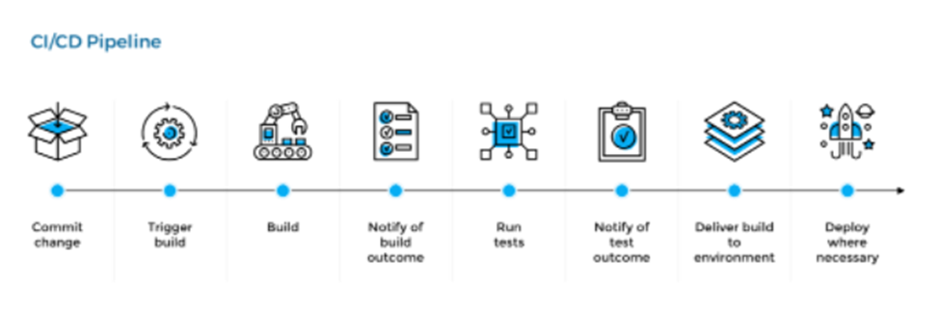

The goal of DevOps is to

· Accelerate Flow - faster delivery

· Amplify Feedback - high quality

· Continuous improvement

**Devops Tools:-**

*Integration tool*:Jenkins, Gitlab or Gitbhub, Docker Hub

*Deployment*:Nginx,terraform,ansible,docker,kubernetes(eks)

*Monitor*:grafana,lens,promotheus, AWS cloudwatch

**IDE:-**

Intellej

visual studio

**CI-CD HLD**:-

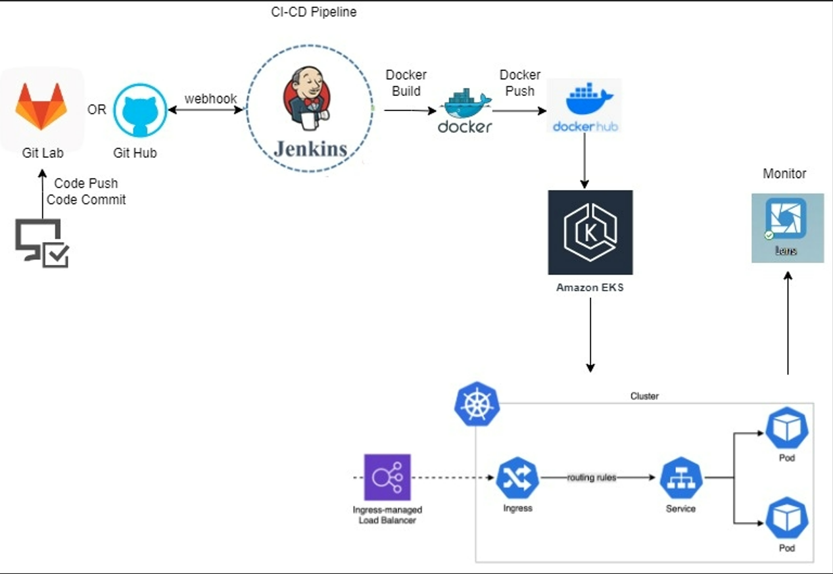

**\*Effort Estimation**

* It is dependent on Content and API requirements. Once it receives the architecture of content and API and Project requirement Document, then it will be estimated.

### MODULE UPDATES (I & D) :

## 

## BACKEND :

| TEAM LEAD | MANUKUMAR BETTASWAMAIAH | manukumar38@gmail.com |
| --- | --- | --- |
| MEMBER | ADITI KEDAR AMDEKAR | aditi.amdekar.13@gmail.com |
| MEMBER | ANJANA PRASAD NAIR | anjanaprasad0910@gmail.com |
| MEMBER | ANUBHAV CHATURVEDI | iamanubhavchaturvedi@gmail.com |
| MEMBER | JAINENDRA KUMAR | jainendrak3@gmail.com |
| MEMBER | JYOTHI | jyothi.n2k9@gmail.com |
| MEMBER | KUMAR MANAS | kumarmanas.real@gmail.com |
| MEMBER | MAYUR RAMNARESH SINGH | singhmayur.ms@gmail.com |
| MEMBER | PARTHIBAN ILANGO | parthibanilango89@gmail.com |
| MEMBER | ROHIT KUMAR SHRIVASTVA | rohit.shrivastva000@gmail.com |
| MEMBER | SAI KRISHNA SWAMY WUDALI | sksw1397@gmail.com |
| MEMBER | SATYSREE CHATTERJEE | satyasreechatterjee@gmail.com |
| MEMBER | SHREYANSH AGRAWAL | shrey20021302@gmail.com |
| MEMBER | VIBHORE GOEL | vibhoregoel915@gmail.com |

* + Development
  + Data Bases design

## 

## FRONT END :

| TEAM LEAD | BALASUBRAMONIAN KUMARESAN | balukumaresan@gmail.com |
| --- | --- | --- |
| MEMBER | AKASH MANKOTIA | akash.mankotia@gmail.com |
| MEMBER | DEBRAJ DAS | debrajdas28@gmail.com |
| MEMBER | MOHAMMED MOHSIN | muhammedmohsin6@gmail.com |
| MEMBER | NIKHIL KUMAR | wwsnikhil@gmail.com |
| MEMBER | PANKAJ PANWAR | pankajpanwar3.98@gmail.com |
| MEMBER | PRANAV SINGH | pranavsinghofficial@gmail.com |
| MEMBER | SHEIK RIAJUDDIN | sk.riyaz97@gmail.com |
| MEMBER | SONALI SHARAD SAGAR | sonaalii.sagar@gmail.com |
| MEMBER | SOPHIA SOLOMON D | sofiasolomon@gmail.com |
| MEMBER | TANYA MEHTA | tmehta169@gmail.com |
| MEMBER | VISHAL SHATAGOPAM | svishalkumar236@gmail.com |

**Front End Content**

**High level flow:** User lands on the Home Page after successful login. Users can see all the articles posted in the Blog. Users can search articles by topic/author etc. Users also can login to the blog using credentials of the site also using facebook/ google credentials. Users can post an article. Users can also edit an article already posted. Users can edit only their articles. Users can subscribe to a payplan to access premium articles.

**Technology** : HTML, CSS, Bootstrap, Javascript, React JS

**Reference Site**: <https://medium.com>

**Literature survey:**

Ease of Navigation

Displaying all the available features/functionality

Search bar for topic title, author etc

Grouping the articles by topics like sports, science etc.

Filters to select articles of specific topic

Titles with icon for each subject

Payment gateway

Easy login experience

Tool tips

**Knowledge Source**

<https://www.ncbi.nlm.nih.gov/pmc/articles/PMC4974011/>

<https://multichannelmerchant.com/blog/payment-gateways-101-examples-benefits-and-drawbacks/>

<https://github.com/ravigithub19/payment-gateway-integration>

<https://www.c-sharpcorner.com/article/login-with-facebook-using-reactjs/#:~:text=npx%20create-react-app%20sociallogin%20Open%20the%20newly-created%20project%20in,using%20the%20following%20command%20npm%20install%20react-facebook-login%20--save>

https://developers.google.com/identity/sign-in/web/sign-in

**Front End Content**

**High level flow:** User lands on the Home Page after successful login. Users can see all the articles posted in the Blog. Users can search articles by topic/author etc. Users also can login to the blog using credentials of the site also using facebook/ google credentials. Users can post an article. Users can also edit an article already posted. Users can edit only their articles. Users can subscribe to a payplan to access premium articles.

**Technology** : HTML, CSS, Bootstrap, Javascript, React JS

**Reference Site**: <https://medium.com>

**Literature survey:**

Ease of Navigation

Displaying all the available features/functionality

Search bar for topic title, author etc

Grouping the articles by topics like sports, science etc.

Filters to select articles of specific topic

Titles with icon for each subject

Payment gateway

Easy login experience

Tool tips

**Knowledge Source**

<https://www.ncbi.nlm.nih.gov/pmc/articles/PMC4974011/>

<https://multichannelmerchant.com/blog/payment-gateways-101-examples-benefits-and-drawbacks/>

<https://github.com/ravigithub19/payment-gateway-integration>

<https://www.c-sharpcorner.com/article/login-with-facebook-using-reactjs/#:~:text=npx%20create-react-app%20sociallogin%20Open%20the%20newly-created%20project%20in,using%20the%20following%20command%20npm%20install%20react-facebook-login%20--save>

https://developers.google.com/identity/sign-in/web/sign-in

## 

## TESTING :

| TEAM LEAD | RAJEEV | r.rajeev434@gmail.com |
| --- | --- | --- |
| MEMBER | AYUSH MER | ayushmer4@gmail.com |
| MEMBER | HARSHITA KURMALA | hkurmala@gmail.com |
| MEMBER | KANCHANA K | joenkanchu@gmail.com |
| MEMBER | MANGESH KORE | mangeshkore151031@gmail.com |
| MEMBER | MAYURI MUSALGAONKAR | mayuridafne5@gmail.com |
| MEMBER | N A AMOGH | amoghnadadur2@gmail.com |
| MEMBER | NANDHINI J | haritha.jagannathan@gmail.com |
| MEMBER | PIYUSH SAHANI | piyushsahani@outlook.com |
| MEMBER | RACHIT KUMAR RASTOGI | rachitrastogi777@gmail.com |
| MEMBER | ROHINA NAAZ | rohinanaaz@gmail.com |
| MEMBER | SASIDARAN J A | sasidaranja@gmail.com |
| MEMBER | SOUMALYA KHAN | toast.maketext@gmail.com |

## 

## DOCUMENTATION :

| TEAM LEAD | SUNIL KUMAR K K | sunnairkk@gmail.com |
| --- | --- | --- |
| MEMBER | ISHA AGARWAL | ishamittal1989@gmail.com |
| MEMBER | JATIN SACHINDRA KUKADE | jatinkukade01@gmail.com |

Technology :

Google Docs, Overleaf.

# PROJECT TEAM

| MODULES | ROLES | **NAMES** | **EMAILID** |
| --- | --- | --- | --- |
|  |  |  |  |
| PROJECT | CONSULTANT | VIPLOV MADAN | iammadan009@gmail.com |
|  |  |  |  |
| PROJECT | PM | SHYAM NAIR | shyam.ravinair@gmail.com |
|  |  |  |  |
| AIML | TEAM LEAD | BHARAT VASIREDDY | bharat.vasireddy@gmail.com |
|  | MEMBER | ANUBHAV GANGWAR | anubhavgangwar98@gmail.com |
|  | MEMBER | ARYAN SHUKLA | shuklas2002@gmail.com |
|  |  |  |  |
| BACKEND | TEAM LEAD | MANUKUMAR BETTASWAMAIAH | manukumar38@gmail.com |
|  | MEMBER | ADITI KEDAR AMDEKAR | aditi.amdekar.13@gmail.com |
|  | MEMBER | ANJANA PRASAD NAIR | anjanaprasad0910@gmail.com |
|  | MEMBER | ANUBHAV CHATURVEDI | iamanubhavchaturvedi@gmail.com |
|  | MEMBER | JAINENDRA KUMAR | jainendrak3@gmail.com |
|  | MEMBER | JYOTHI | jyothi.n2k9@gmail.com |
|  | MEMBER | KUMAR MANAS | kumarmanas.real@gmail.com |
|  | MEMBER | MAYUR RAMNARESH SINGH | singhmayur.ms@gmail.com |
|  | MEMBER | PARTHIBAN ILANGO | parthibanilango89@gmail.com |
|  | MEMBER | ROHIT KUMAR SHRIVASTVA | rohit.shrivastva000@gmail.com |
|  | MEMBER | SAI KRISHNA SWAMY WUDALI | sksw1397@gmail.com |
|  | MEMBER | SATYSREE CHATTERJEE | satyasreechatterjee@gmail.com |
|  | MEMBER | SHREYANSH AGRAWAL | shrey20021302@gmail.com |
|  | MEMBER | VIBHORE GOEL | vibhoregoel915@gmail.com |
|  |  |  |  |
| DATA ENGINEERING | TEAM LEAD | MONIDEEPA ROY | roy.monideepa@gmail.com |
|  | MEMBER | DIGVIJAY KUMAR | dgvj.kmr@gmail.com |
|  | MEMBER | NARENDRA KUMAR | naren.dsp@gmail.com |
|  | MEMBER | NIKHIL THORAWADE | nikhil.t.career@gmail.com |
|  | MEMBER | PASUPULETI VENKATESWARA RAO | pvrpasupuleti.r1@gmail.com |
|  |  |  |  |
| DOCUMENTATION | TEAM LEAD | SUNIL KUMAR K K | sunnairkk@gmail.com |
|  | MEMBER | ISHA AGARWAL | ishamittal1989@gmail.com |
|  | MEMBER | JATIN SACHINDRA KUKADE | jatinkukade01@gmail.com |
|  |  |  |  |
| FRONT END | TEAM LEAD | BALASUBRAMONIAN KUMARESAN | balukumaresan@gmail.com |
|  | MEMBER | AKASH MANKOTIA | akash.mankotia@gmail.com |
|  | MEMBER | DEBRAJ DAS | debrajdas28@gmail.com |
|  | MEMBER | MOHAMMED MOHSIN | muhammedmohsin6@gmail.com |
|  | MEMBER | NIKHIL KUMAR | wwsnikhil@gmail.com |
|  | MEMBER | PANKAJ PANWAR | pankajpanwar3.98@gmail.com |
|  | MEMBER | PRANAV SINGH | pranavsinghofficial@gmail.com |
|  | MEMBER | SHEIK RIAJUDDIN | sk.riyaz97@gmail.com |
|  | MEMBER | SONALI SHARAD SAGAR | sonaalii.sagar@gmail.com |
|  | MEMBER | SOPHIA SOLOMON D | sofiasolomon@gmail.com |
|  | MEMBER | TANYA MEHTA | tmehta169@gmail.com |
|  | MEMBER | VISHAL SHATAGOPAM | svishalkumar236@gmail.com |
|  |  |  |  |
| INTEGRATION & DEPLOYMENT | TEAM LEAD | NARAYANAN KESAVAN | kesavannarayanan@gmail.com |
|  | MEMBER | AKSHIT BAUNTHIYAL | akshit.baunthy@gmail.com |
|  | MEMBER | ANSHUL VANAWAT | anshulv1401@gmail.com |
|  | MEMBER | ARUNKUMAR S | arunkumar.s.85@gmail.com |
|  | MEMBER | GILSON PAUL GEORGE | gilsonpgeorge300@gmail.com |
|  | MEMBER | GOWTHAM PADMANATHAN | padmanathan.gowtham@gmail.com |
|  | MEMBER | RAJIB DEB | rajib.deb1991@gmail.com |
|  |  |  |  |
| TESTING | TEAM LEAD | VENKATESH RAPOLU | venkateshrapolu2008@gmail.com |
|  | MEMBER | ABHISHEK SRIVASTAVA | abhstv947@gmail.com |
|  | MEMBER | AJAI KRISHNA J M | jmajaikrishna333@gmail.com |
|  | MEMBER | AKSHAY KUMAR | akshaykr2k16@gmail.com |
|  | MEMBER | BHAGYASHRI PEDAPALLIKAR | bhagyashripedapallikar@gmail.com |
|  | MEMBER | BHARGAVI | bhargavipittala1999@gmail.com |
|  | MEMBER | BIKRAM KUMAR SINGH | bikramkumarsingh49@gmail.com |
|  | MEMBER | DAME IAKI KHARPURI | kharpurid@gmail.com |
|  | MEMBER | KUSUMA VARSHITH | kusuma.varshith22@gmail.com |
|  | MEMBER | MANUSHRI SHARMA | manushri.sharma1@gmail.com |
|  | MEMBER | RAHUL AWASTHI | rahul.awasthi200@gmail.com |
|  | MEMBER | SONIA DAGAR | prempuran1010@gmail.com |
|  |  |  |  |
| MOBILE APP | TEAM LEAD | RAJEEV | r.rajeev434@gmail.com |
|  | MEMBER | AYUSH MER | ayushmer4@gmail.com |
|  | MEMBER | HARSHITA KURMALA | hkurmala@gmail.com |
|  | MEMBER | KANCHANA K | joenkanchu@gmail.com |
|  | MEMBER | MANGESH KORE | mangeshkore151031@gmail.com |
|  | MEMBER | MAYURI MUSALGAONKAR | mayuridafne5@gmail.com |
|  | MEMBER | N A AMOGH | amoghnadadur2@gmail.com |
|  | MEMBER | NANDHINI J | haritha.jagannathan@gmail.com |
|  | MEMBER | PIYUSH SAHANI | piyushsahani@outlook.com |
|  | MEMBER | RACHIT KUMAR RASTOGI | rachitrastogi777@gmail.com |
|  | MEMBER | ROHINA NAAZ | rohinanaaz@gmail.com |
|  | MEMBER | SASIDARAN J A | sasidaranja@gmail.com |
|  | MEMBER | SOUMALYA KHAN | toast.maketext@gmail.com |